T3 DQ2

For Major Assignment 2 in Topic 4, you will look ahead at your financial plan after graduation. For this DQ, you will look ahead at the assignment instructions and take some time to think about what you will need to do for this assignment.
Start by reviewing the instructions for Major Assignment 2. There are several sections to the written project; here we ask you to complete just one. Each section has its own set of questions.
There is a template for the written portion as well as an Excel template in the Topic 4 tab in Halo. (See below.) In particular,
- Use MS Word and use the provided template. Leave the headings, except the Title, which you will change, as they are.
- Each section has multiple questions. You should have a separate, well-formed paragraph for each question asked, not a list and not a single-sentence response.
- You must cite your sources in your work, and for this DQ we ask that you have at least one academic source.
For this DQ, complete the following three items using the template for the written portion of Major Assignment 2 (see below) and upload your work as usual to the DQ forum.
- Title
Set the Title, Name, Instructor's Name, etc.
- Income and Projection

- Considering real-world expenses upon graduation, what careers in your program of study are likely to provide enough net income to cover these expenses? Here, you may want to give a broad estimate of your expected monthly or yearly expenses, along with a broad salary estimate. Remember also to think about the effect of taxes on your net income.
- Under what conditions might not having enough income to cover expenses still work out all right in the longer run?

- References
For this DQ, use at least one academic source. MA2 asks for at least three with a minimum of five total sources.
For example:
For a Book:
Author, A. A. (Year). Title of book (Edition if applicable). Publisher.
For a Journal Article:
Author, A. A., & Author, B. B. (Year). Title of the article. Journal Name, Volume(Issue), Page numbers. https://doi.org/xxxx
For a Website:
Author, A. A. (Year, Month Date). Title of the webpage. Website Name. URL
For an AI Model (e.g., ChatGPT):
OpenAI. (Year). Title of the AI model (version) [Large language model]. Company Name. URL
The template is named MAT-144-RS-ONL-T4-Major Assignment 2 Write-up Template Online 20260126.docx. The instructions document is MAT-144-RS-ONL-T4-Major Assignment 2 Instructions Online 20260126.docx
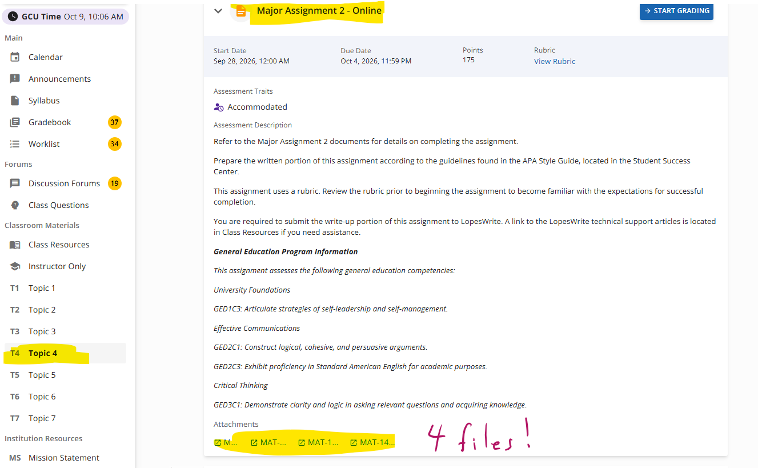

Do not post more than we ask here; the major assignments are used like exams, and you should not post completed work in a public forum.

